Question 1: Motion in the $xy$-plane
A particle moves in the $xy$-plane. Its position coordinates are given by
$x=5+3t$and $y=2t^{2}+9t+18$where $x$ and $y$ are measured in meters, and $t$ is measured in seconds.
(a) Determine the initial position vector of the particle at $t=0$, in terms of the unit vectors $\hat{i}$ and $\hat{j}$.
(b) Express the velocity vector $\vec{v}$ of the particle in terms of $\hat{i}$and $\hat{j}$.
(c) Express the acceleration vector $\vec{a}$of the particle in terms of $\hat{i}$and $\hat{j}$.

Question 2: Free fall from a building
A small stone is released from rest from the top of a building. It reaches the ground after 3.00 s. Neglect air resistance and assume the stone undergoes free fall.
(a) Calculate the height of the building in meters.
(b) Find the magnitude of the stone’s velocity just before it hits the ground.
(c) Sketch the $a_{y}$-$t$ graph for the motion of the stone.

Question 3: Centripetal acceleration
A student rides on a Ferris wheel of radius 12 m. The wheel completes 4 revolutions per minute about its horizontal axis.
(a) What is the period of the motion?
(b) What is the magnitude of the student’s centripetal acceleration at the highest point?
(c) What is the direction of the centripetal acceleration at the highest point?
(d) What is the magnitude of the student’s centripetal acceleration at the lowest point?
(e) What is the direction of the centripetal acceleration at the lowest point?

Question 4: Frictional force
As shown in the figure, two blocks are connected by a light rope and pulled along a horizontal rough surface by an external horizontal force. Suppose $F=75.0\text{ N},m_{1}=10.0\text{ kg},m_{2}=20.0\text{ kg},$and the coefficient of kinetic friction between each block and the surface is $μ_{k}=0.120.$
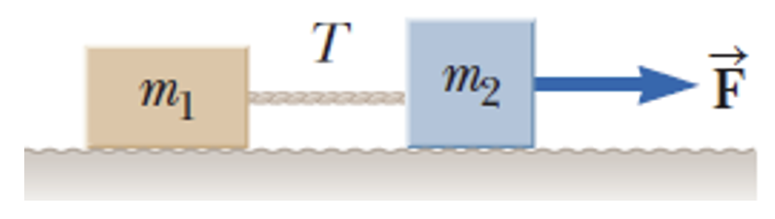
Determine:
(a) the acceleration of the two-block system,
(b) the tension $T$in the rope.

Question 5: Frictional force
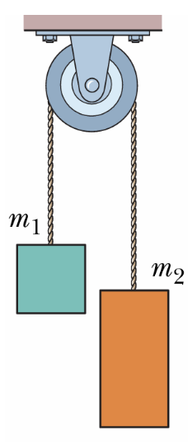
The figure shows two blocks connected by a light cord passing over a frictionless pulley of negligible mass. This setup is an Atwood machine. The two blocks have masses $m_{1}=1.50\text{ kg}$and $m_{2}=3.00\text{ kg}.$
Assuming the cord does not stretch and air resistance is negligible, determine:
(a) the magnitude of the acceleration of the two blocks,
(b) the tension $T$ in the cord.

Question 6: Projectile motion
A small marble rolls horizontally off the edge of a table that is 1.80 m above the floor. It lands 2.40 m horizontally from the edge of the table.
(a) How long does the marble remain in the air?
(b) What is the marble’s horizontal speed as it leaves the table?

Question 7
(a) A solid sphere with mass 0.100 kg and radius 0.020 m, initially at rest, rolls down a curved surface without slipping through height $h$meters. The translational speed of the center of mass of the solid sphere at the bottom of the surface, $v_{\text{bottom}}$, is 13.0 m/s.
The moment of inertia of a solid sphere with mass $M$and radius $R$rotating about its center is given by $I_{\text{CM}}^{\text{sphere}}=\frac{2}{5}MR^{2}.$
(i) Determine the value of $h$.
(ii) If a hollow sphere of the same mass instead of a solid sphere is used, will $v_{\text{bottom}}$increase, decrease or remain the same? The moment of inertia of a hollow sphere is $I=\frac{2}{3}MR^{2}.$
(b) The solid sphere then sticks to a uniform rod of mass 3.00 kg and length 1.60 m. The rod pivots about point $O$in the vertical plane.
(i) If the moment of inertia of the rod rotating about its center of mass is given by $0.64 {\text{kg m}}^{2},$calculate the moment of inertia of the rod rotating about $O$.
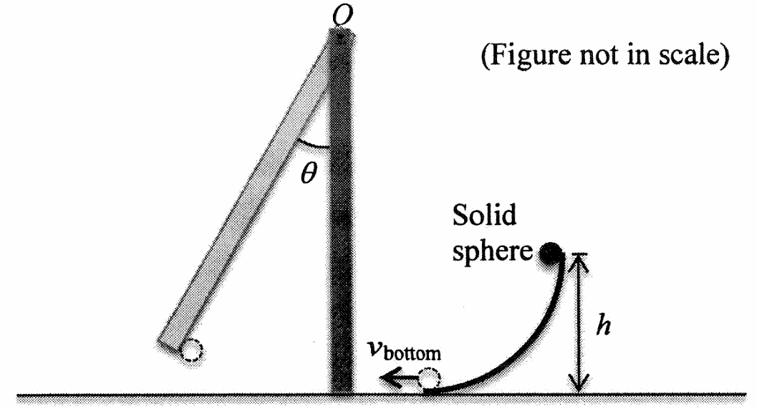

Question 8
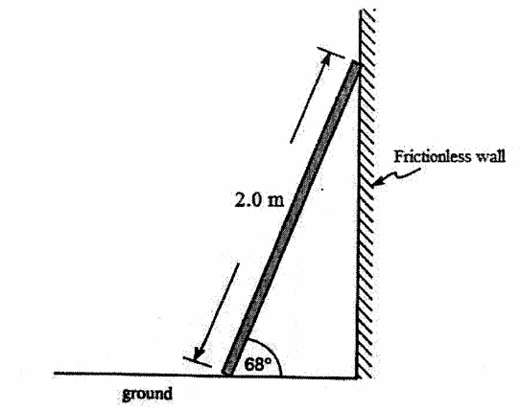
(a) A ladder leans against a frictionless wall as shown in Figure B3. The ladder has a mass of 6.0 kg and a length of 2.0 m.
(i) Draw a free body diagram for the ladder.
(ii) Find the normal force the wall exerts on the ladder.
(iii) Find the frictional force the floor exerts on the ladder.

(b) Peter’s mass is 65 kg. He plans to climb up the above ladder (Figure B3) and sit on the top. The largest possible static friction that can be supported at the contact between the ladder and the floor is 200 N.
(i) Without the help of another person, can Peter safely sit on the top of the ladder? Explain.
(ii) James tries to push the middle of the ladder by applying a horizontal force. What is the magnitude of the force James should provide so that Peter can sit safely on the top of the ladder?

Question 9
As shown in Fig, a wheel with radius $R=0.23\text{ m}$and mass $M=1.2\text{ kg}$is rolling down an inclined plane. The moment of inertia of the wheel is $I=MR^{2},$and the wheel rolls without slipping. The angle $ϕ$of the incline is unknown. The wheel begins to roll down from rest.
(a) After 6.3 seconds the wheel rotates at an angular velocity of $41.3\text{ rad/s}.$How many turns, or revolutions, does the wheel rotate during that time?
(b) Find the distance traveled by the wheel along the incline.
(c) What is the angle $ϕ$ of the incline?
(d) Find the magnitude of the static frictional force between the wheel and the incline.
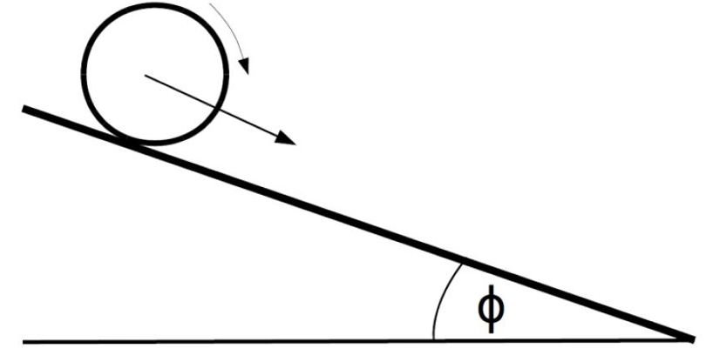

Question 10
A massless string is wound around a uniform disk of radius R = 0.20 m and mass M = 0.80 kg. The disk is released from rest with the string vertical and its top end tied to a fixed bar as shown in Figure. The moment of inertia of a uniform disk rotating about an axis through its center and perpendicular to disc is given by I = MR²/2.
(a) Determine the tension in the string and the magnitude of the acceleration of the center of mass.
(b) Determine the time required for the disk to descend through a distance h = 0.6 m.
(d) Determine the angular speed of the disk after it has descended through a distance h = 0.6 m.
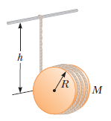

11. A 0.200-kg frame made of silver is suspended from a coil spring (shown in the figure below), stretching the spring 0.060 m. A 0.180-kg lump of clay 0.250 m above the frame is dropped from rest onto the frame. Neglecting friction and air resistance, what is the maximum distance the frame will move downward from its initial position?
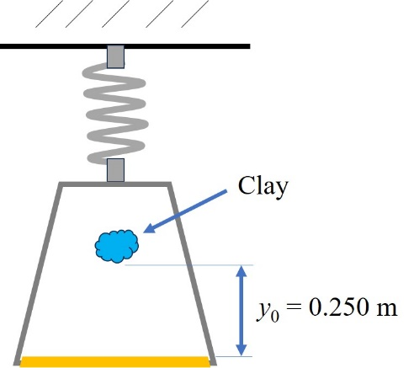

12. You drive a car weighing 7,848 N and check the speedometer at two instances: the first reading is v₀ = 10.0 m/s and 10.0 s later the speed increased to v₁ = 15.0 m/s. Note that the altitude of the car during these two readings are the same. (a) How much work did the car do on you during this interval? Neglect all frictional forces. (b) At the exact moment during the second reading of v₁, you were at the edge of a hill (see figure below) so you turned off the engine and the car coasts downhill. After descending 50 m in altitude, what is the speed of your car?
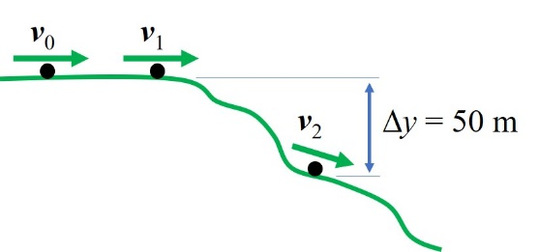

Answer Key
Question 1
Given:
$$x=5+3t \\ y=2t^{2}+9t+18$$
The position vector is
$$\vec{r}=x\hat{i}+y\hat{j}$$
(a) Initial position at $t=0$
$$x(0)=5 \\ y(0)=18$$
Therefore,
$${\vec{r}}_{0}=5\hat{i}+18\hat{j}\text{ m}$$

(b) Velocity vector
$$\vec{v}=\frac{dx}{dt}\hat{i}+\frac{dy}{dt}\hat{j} \\ \frac{dx}{dt}=3 \\ \frac{dy}{dt}=4t+9$$
Therefore,
$$\vec{v}=3\hat{i}+(4t+9)\hat{j} {\text{m s}}^{-1}$$

(c) Acceleration vector
$$\vec{a}=\frac{d\vec{v}}{dt} \\ a_{x}=0 \\ a_{y}=4$$
Therefore,
$$\vec{a}=4\hat{j} {\text{m s}}^{-2}$$
or
$$\vec{a}=0\hat{i}+4\hat{j} {\text{m s}}^{-2}$$

Question 2
Given:
$$u=0 \\ t=3.00\text{ s} \\ g=9.8 {\text{m s}}^{-2}$$
Taking downward as positive.
(a) Height of the building
$$s=ut+\frac{1}{2}gt^{2} \\ s=0+\frac{1}{2}(9.8)(3.00)^{2} \\ s=44.1\text{ m}$$
Therefore, the building is
$$44.1\text{ m}$$
tall.

(b) Velocity just before impact
$$v=u+gt \\ v=0+(9.8)(3.00) \\ v=29.4 {\text{m s}}^{-1}$$
Therefore, the magnitude of the velocity just before reaching the ground is
$$29.4 {\text{m s}}^{-1}$$

(c) $a_{y}$-$t$ graph
If upward is taken as positive, then
$$a_{y}=-9.8 {\text{m s}}^{-2}$$
The graph is a horizontal straight line at
$$a_{y}=-9.8 {\text{m s}}^{-2}$$
from $t=0$to $t=3.00\text{ s}$.

Answer Key
Given:
$$r=12\text{ m}$$
The Ferris wheel makes
$$4\text{ rev/min}$$
Since
$$1\text{ min}=60\text{ s}$$
the frequency is
$$f=\frac{4}{60}=\frac{1}{15}\text{ Hz}$$

Q3
(a) Period of the motion
$$T=\frac{1}{f} \\ T=15\text{ s}$$
So the period is
$$\boxed{15\text{ s}}$$

(b) Magnitude of centripetal acceleration
The centripetal acceleration is
$$a_{c}=\frac{v^{2}}{r}$$
or equivalently,
$$a_{c}=ω^{2}r$$
where
$$ω=2πf \\ ω=2π\left(\frac{1}{15}\right) \\ ω=\frac{2π}{15} {\text{rad s}}^{-1}$$
Therefore,
$$a_{c}={\left(\frac{2π}{15}\right)}^{2}(12) \\ a_{c}≈2.11 {\text{m s}}^{-2}$$
So the magnitude is
$$\boxed{2.11 {\text{m s}}^{-2}}$$

(c) Direction at the highest point
Centripetal acceleration always points toward the center of the circular path.
At the highest point, the center of the Ferris wheel is below the rider.
Therefore, the centripetal acceleration is directed:
$$\boxed{\text{downward}}$$

(d) Magnitude at the lowest point
The speed and radius are the same everywhere in uniform circular motion, so the magnitude of centripetal acceleration is the same:
$$\boxed{2.11 {\text{m s}}^{-2}}$$

(e) Direction at the lowest point
At the lowest point, the center of the Ferris wheel is above the rider.
Therefore, the centripetal acceleration is directed:
$$\boxed{\text{upward}}$$Answer Key
Given
$$F=75.0\text{ N} \\ m_{1}=10.0\text{ kg},m_{2}=20.0\text{ kg} \\ μ_{k}=0.120$$
Take
$$g=9.8 {\text{m s}}^{-2}$$

Ans Q4
(a) Acceleration of the system
Treat the two blocks as one system.
The total mass is
$$m_{1}+m_{2}=10.0+20.0=30.0\text{ kg}$$
The total kinetic friction is
$$f_{k}=μ_{k}(m_{1}+m_{2})g \\ f_{k}=(0.120)(30.0)(9.8) \\ f_{k}=35.28\text{ N}$$
The net force is
$$F_{\text{net}}=75.0-35.28 \\ F_{\text{net}}=39.72\text{ N}$$
Therefore,
$$a=\frac{F_{\text{net}}}{m_{1}+m_{2}} \\ a=\frac{39.72}{30.0} \\ a=1.324 {\text{m s}}^{-2}$$
So,
$$\boxed{a≈1.32 {\text{m s}}^{-2}}$$
to the right.

(b) Tension in the rope
Consider block $m_{1}$.
For $m_{1}$, the horizontal forces are:
- tension $T$to the right,
- kinetic friction $f_{k1}$to the left.
The friction on $m_{1}$is
$$f_{k1}=μ_{k}m_{1}g \\ f_{k1}=(0.120)(10.0)(9.8) \\ f_{k1}=11.76\text{ N}$$
Using Newton’s second law:
$$T-f_{k1}=m_{1}a \\ T=m_{1}a+f_{k1} \\ T=(10.0)(1.324)+11.76 \\ T=25.0\text{ N}$$
Therefore,
$$\boxed{T≈25.0\text{ N}}$$

Final Answers
$$\boxed{a=1.32 {\text{m s}}^{-2}\text{ to the right}} \\ \boxed{T=25.0\text{ N}}$$

Ans:6
Answer Key
Given:
$$h=1.80\text{ m} \\ x=2.40\text{ m} \\ g=9.8 {\text{m s}}^{-2}$$
The initial vertical velocity is zero because the marble leaves the table horizontally.

(a) Time in the air
Use the vertical motion:
$$h=\frac{1}{2}gt^{2} \\ t=\sqrt{\frac{2h}{g}} \\ t=\sqrt{\frac{2(1.80)}{9.8}} \\ t=\sqrt{0.367} \\ t=0.606\text{ s}$$
Therefore,
$$\boxed{t≈0.61\text{ s}}$$

(b) Speed as it leaves the table
The horizontal speed is constant:
$$v_{x}=\frac{x}{t} \\ v_{x}=\frac{2.40}{0.606} \\ v_{x}=3.96 {\text{m s}}^{-1}$$
Therefore,
$$\boxed{v_{x}≈4.0 {\text{m s}}^{-1}}$$

Final Answers
$$\boxed{t=0.61\text{ s}} \\ \boxed{v_{x}=4.0 {\text{m s}}^{-1}}$$

Ans Q7
(a)(i)
$$\frac{1}{2}I_{CM}{\left(\frac{v_{CM}}{R}\right)}^{2}+\frac{1}{2}Mv_{CM}^{2}=Mgh \\ h=\frac{7v_{CM}^{2}}{10g}=12.1\text{ m}$$

(a)(ii)
decrease

(b)(i)
$$I_{O}^{rod}=I_{CM}^{rod}+MD^{2}=0.64+3{\left(\frac{1.6}{2}\right)}^{2}=2.56 {\text{kg m}}^{2}$$

(b)(ii)
$$L_{f}=L_{i} \\ \left(I_{O}^{rod} + ML^{2}\right)ω=MLv \\ \left(2.56+0.1×{1.6}^{2}\right)ω=0.1×1.6×13 \\ ω=0.739\text{ rad/s}$$

(c)
$$m_{rod}g\frac{L}{2}(1-cos⁡θ)+m_{sphere}gL(1-cos⁡θ)=\frac{1}{2}I_{total}ω^{2} \\ θ={cos⁡}^{-1}\left(1 − \frac{I_{total}ω^{2}}{2(0.5×m_{rod}+m_{sphere})gL}\right)={14.2}^{∘}$$

Ans Q8
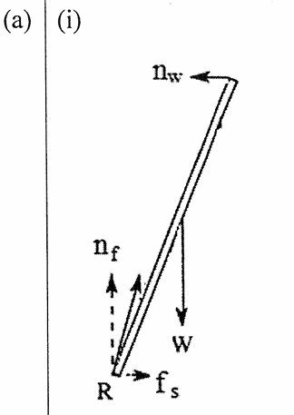
(a)(ii)
Balance of torque about bottom contact point:
$$n_{w}lsin⁡θ=mg\left(\frac{l}{2}\right)cos⁡θ \\ ⇒n_{w}=\frac{mg}{2tan⁡θ}=12\text{ N}$$

(a)(iii)
$$∑F_{x}=0 \\ ⇒f_{s}=n_{w}=12\text{ N}$$

(b)(i)
Balance of torque about bottom contact point:
$$n_{w}lsin⁡θ=mg\left(\frac{l}{2}\right)cos⁡θ+Mglcos⁡θ$$
and
$$∑F_{x}=0 \\ ⇒f_{s}=n_{w}=\frac{\left(\frac{m}{2} + M\right)}{\tan{θ}}g=269\text{ N}>200\text{ N}=f_{s,max⁡}$$
This result contradicts with the fact
$$f_{s}<f_{s,max⁡}$$
and thus the ladder will slide down.

(b)(ii)
Balance of torque about the top contact point:
$$F\left(\frac{l}{2}\right)sin⁡θ+f_{s}lsin⁡θ+mg\left(\frac{l}{2}\right)cos⁡θ=n_{g}lcos⁡θ$$
and
$$∑F_{y}=0 \\ ⇒F=\frac{2n_{g}-mg}{\tan{θ}}-2f_{s}$$
and
$$n_{g}=(m+M)g \\ F=\frac{2Mg+mg}{\tan{θ}}-2f_{s}≥538\text{ N}-2(200\text{ N})≈140\text{ N}$$

Ans Q9
(a)
The wheel rolls with a constant angular acceleration.
$$α=\frac{ω_{f}}{t} \\ θ_{f}=\frac{1}{2}αt^{2}=\frac{ω_{f}t}{2}$$
Number of turns:
$$n=\frac{θ}{2π}=\frac{ω_{f}t}{4π}=20.7$$

(b)
The linear acceleration is
$$a=Rα$$
Distance traveled:
$$L=\frac{1}{2}at^{2}=\frac{Rω_{f}t}{2}=29.9\text{ m}$$

(c)
Choose the axis of rotation at the point of contact, we have
$$τ=MgRsin⁡ϕ=\left(I_{cm} + MR^{2}\right)α \\ sin⁡ϕ=\frac{2MR^{2}α}{MgR}=\frac{2Rω_{f}}{gt} \\ ⇒ϕ={17.9}^{∘}$$

Ans 10.
(a) | and
(b) | t = 0.428s
(c) | v=2.80  Or  =14.0rad/s

11. Answer:

m_{f} = 0.200 kg
m_{c} = 0.180 kg
y₁ = 0.060 m
y₀ = 0.250 m

The frame is initially at rest, so Newton’s first Law equation is:

ΣF_{y} = ky₁ – w = 0, or ky₁ = mg, so that the spring constant is k = m_{f}*g / y₁ = [0.200 kg * 9.81 m/s² ] / 0.060 m = 32.7 N/m.

First apply conservation of energy: the total energy of the clay before it is dropped (instant 1) must equal to the total energy of the clay before hitting the frame (instant 2). This will allow us to determine the clay’s velocity just before hitting the frame.

K₁ + U₁ = K₂ + U₂, where K₁ and U₂ both equal to zero.
U₁ = m_{c}gy₀ = 0.180 kg * 9.81 m/s² * 0.250 m = 0.441 J
K₂ = 0.5m_{c}v_{c}², substitution yields v_{c} = 2.21 m/s.

We now apply conservation of momentum for complete inelastic collision to determine the velocity after the clay sticks onto the frame:

m_{c}*v_{c} + m_{f}*v_{f} = [m_{c} + m_{f}]v_{t}, note that the initial velocity of the frame v_{f} = 0 because it started from rest. Here, the calculated v_{t} = 1.05 m/s, is the velocity of the 'total' masses of the clay plus the frame after the 'collision'.

Lastly, we need to apply conservation of energy again.

K₃ + U_{3e} + U_{3g} = K₄ + U_{4e} + U_{4g}

Note that there are now both an elastic and gravitational potential energy, U_{e} and U_{g}, respectively. The origin must be set to the position where the spring is at its equilibrium.

K₃ = 0.5*[m_{c} + m_{f}]*v_{t}² = 0.209 J.
U_{3e} = 0.5*k*(0.060 m)² = 0.059 J, the initially stretched position of y₁ = 0.060 m was given in the problem.
U_{3g} = [m_{c} + m_{f}]*g*(–0.06 m) = –0.223 J.
K₄ = 0, this is because the velocity of the combined masses is zero at the lowest point.
U_{4e} = 0.5*k*[(0.060 m) + y]² = 0.5*k[(0.0036 m²) + (0.12 m) * y + y²].
U_{4g} = [m_{c} + m_{f}]*g*[(–0.06 m) + y)] = –0.224 J + (3.73 N)*y.

Substitution into the conservation of energy equation yields the following quadratic equation:

0.045 J = 0.059 J + (1.96 N) * y + (16.4 N/m) * y² + –0.224 J + (3.73 N)*y

Doing without the units and solving for y:

16.4 y² + 5.69 y – 0.210 = 0

We obtain two answers, 0.034 m and –0.381 m, the positive and negative answers represent the maximum and minimum positions, respectively. Hence, the maximum total distance the frame will move downward is–0.381 m.

12. Answer:

Given information:
Mass of car is (7,848 N) / (9.81 m/s) = 800 kg
Plot the following two points: (t₀, v₀) and (t₁, v₁) on a v vs. t graph to obtain:
(0, 10 m/s) and (10 s, 15 m/s).

Connect the two points. The slope of this line is the acceleration a and the area underneath this line is the total distance s covered.

This can be treated as a 1-D motion type of problem so vector notation is not needed.
a_{x} = a = [(15 m/s) – (10 m/s)] / (10 s) = 0.5 m/s² (slope)
s = s = [10 s] * [(15 m/s) + (10 m/s)] / 2 = 125 m (area below)
W = F · s = ma*s = (800 kg)*(0.5 m/s²)*(125 m) = 50 kN

At the edge of the hill, the total energy of the car is
E = K₁ + U₁ = 0.5mv₁² + mgy₁ = 0.5*(800 kg)*(15 m/s)² + 0 = 90 kJ, the potential energy at this instant is 0 because I picked the top of the hill to be the origin, namely, y₁ = 0.

We then apply conservation of energy, so after descending 50 m, E is still 90 kJ.
K₂ + U₂ = 0.5mv₂² + mgy₂ = 0.5*(800 kg)*v₂² + (800 kg)*(9.81 m/s²)*(–50 m) = 90 kJ
v₂ = 34.7 m/s

